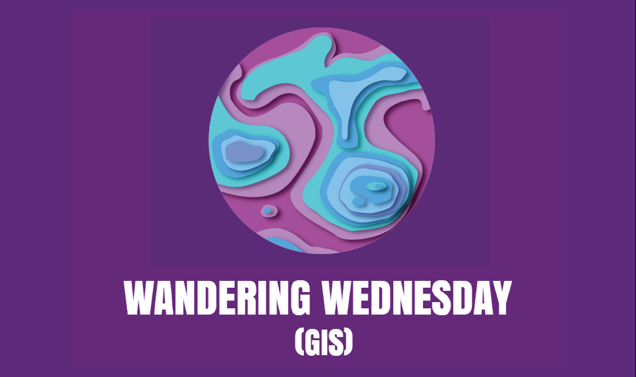

ACTIVITY
Latitude and Longitude

Using Google Earth

Latitude and Longitude is a grid system that is used by humans to give a geographic address to each point on the Earth’s surface. Latitude is consisted of concentric circles that circle the earth called parallels. Longitude can be defined as an arbitrary north-south line between the two geographical poles. Lines of longitude are referred to as meridians. Google Earth has the latitude and Longitude coordinates built in to the program. In this lesson, we will use this tool to find some features and Lat. and Long. coordinates.

Procedure
- Start Google Earth
- Notice: at the bottom right hand corner there are two numbers that change as you move the mouse. These are the latitude and longitude coordinates of the exact location that your mouse is over. The closer you are zoomed in, the more accurate you will be in finding features with coordinates.
- Find these points using the search window. Note: you must copy and paste the coordinates or type in the coordinates into the search window exactly as you see them here including spaces, apostrophes, and quotation marks.

  - Find: 30 16’ 36” N, 81 40’58” W
  - What is this feature?___________________
  - What is its name?______________________
  - What major city is it close to?_____________

- Find 38 53' 40 N, 77 00' 33" W
- What city is this?______________
- Why is it important to the U.S.?___________
- What ocean is this city near?_________

- Find 24 33' 16" N, 81 45' 24" W
- What transportation feature is this?_______
- What are the white things that look like plus signs?________
- What island is this on?___________

- Now places will be given to you and you will have to find the longitude and latitude coordinates that correspond with the place. Note: any point that is over the feature will be acceptable. Look at the bottom left of your screen, the numbers following the word “Pointer” are your coordinates. You can type in key words (e.g. Key West) in the search box to help you find the place.
  - The football stadium at Florida State University
- Lat._____________Long._____________
  - Your School
- Lat._____________Long._____________
  - The Strait of Gibraltar
- Lat._____________Long._____________
  - Honolulu, Hawaii
- Lat._____________Long._____________

- Now just for fun, can you find the location of a Pokémon that you have caught and place it on the map? Try to add a photo if you can!

